FERDOCEAN SHIPPING AS

TERM SHEET CLARIFYING QUESTIONS

Due Diligence Inquiry

Document Classification: Board Review - Confidential
Prepared by: Tore Ausland, BOD
Date: July 17, 2025

EXECUTIVE SUMMARY

The following questions address critical ambiguities and potential concerns identified in the investment term sheet. These inquiries are designed to ensure complete understanding of all financial obligations, timing requirements, and structural implications before proceeding with definitive agreements.

SECTION A: LISTING REQUIREMENTS AND TIMING

**A1. Listing Requirement Clarification**
Question: The term sheet states that shares must be "trading in a liquid market on a national securities exchange" before accessing investment funds. Can you confirm whether this requirement applies to:
- Tranche 1 ($37.5M) - or can this tranche be accessed upon signing definitive agreements? YES it is Required, but see below and understand that listing is what is required to enter tranche 1 and 2, not a IPO.
- All subsequent tranches?
- Is there any scenario where partial funding could be provided during the listing process rather than after completion?

**A2. Acceptable Exchange Definition**
Question: When the term sheet references "national securities exchange (NYSE, NYSE MKT, or any tier of the NASDAQ)," does this include:
- NYSE American (formerly NYSE MKT)?
- NASDAQ Capital Market (the lowest tier)?
- Would Cboe Global Markets qualify as an acceptable alternative?
- Are OTC Markets explicitly excluded, or could OTCQX be considered under any circumstances?
David is sending the IPO listing requirements, we can do it ourselves.
Hiring general council that will work on a salary. 60 days to get listing. 15 questions to be answered. Start the direct listing wit existing management.
The order of action can be

Direct listing _ Access to Tranche 1 and 2 (Low cost and relatively simple and fast.

Draw down on the tranches

IPO
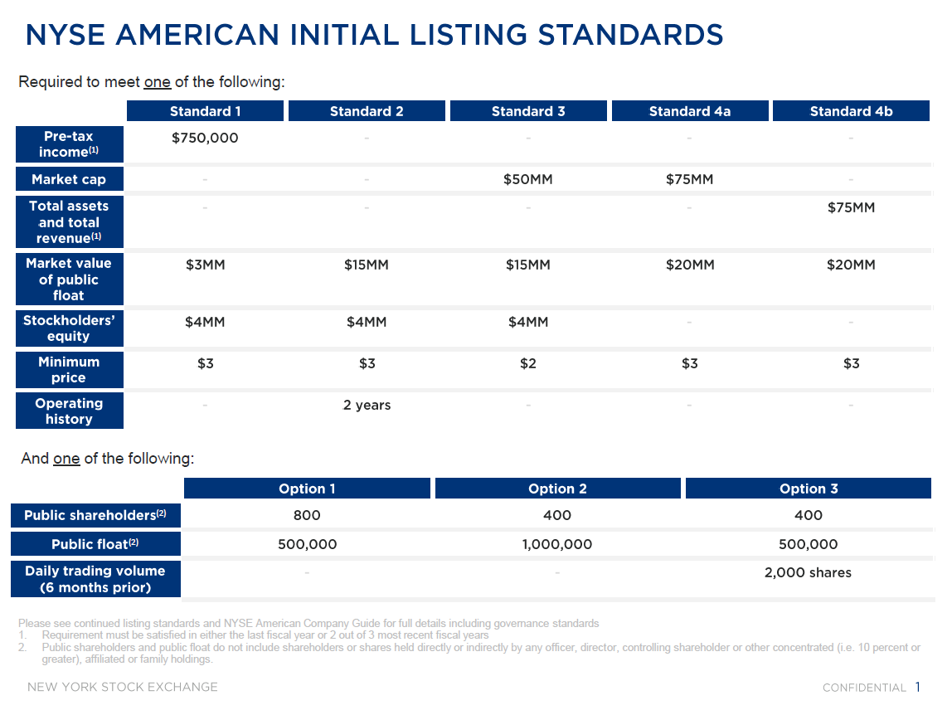

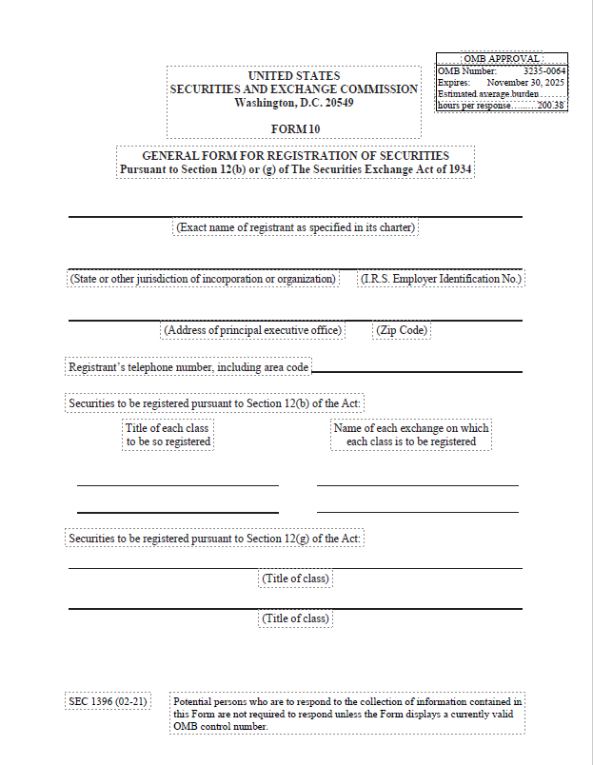
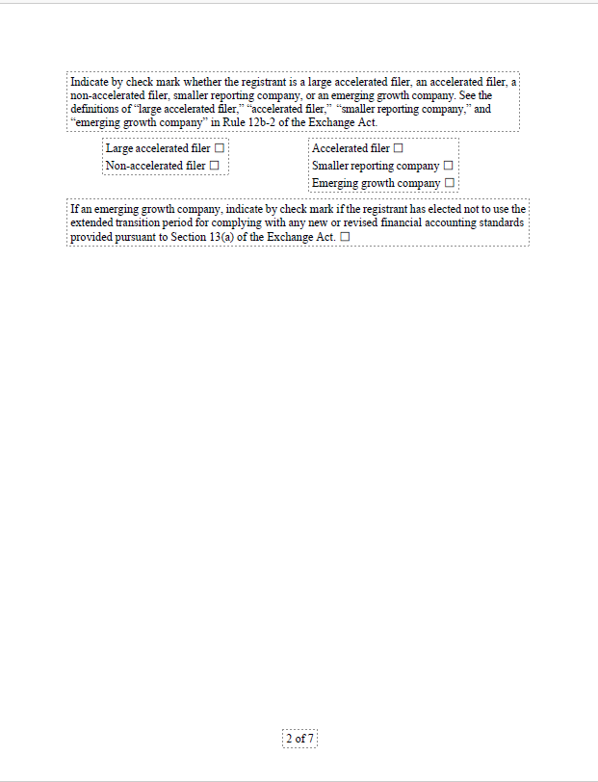
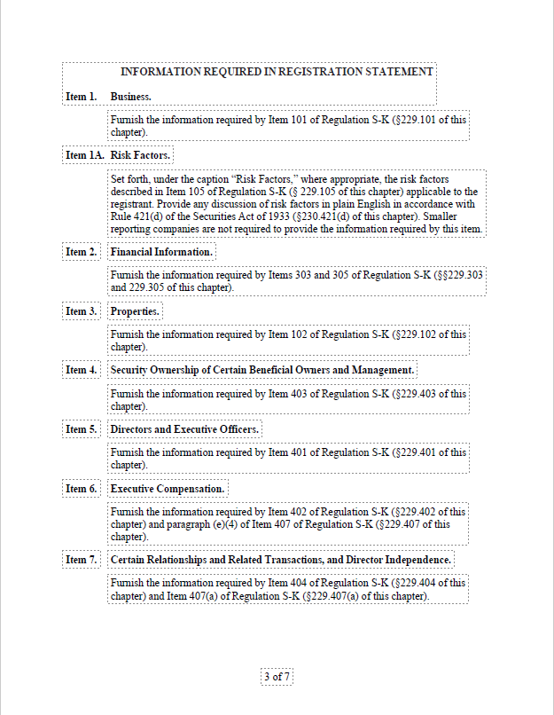
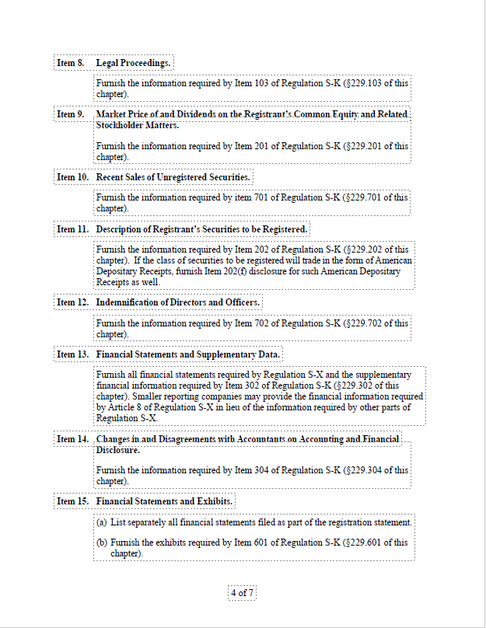
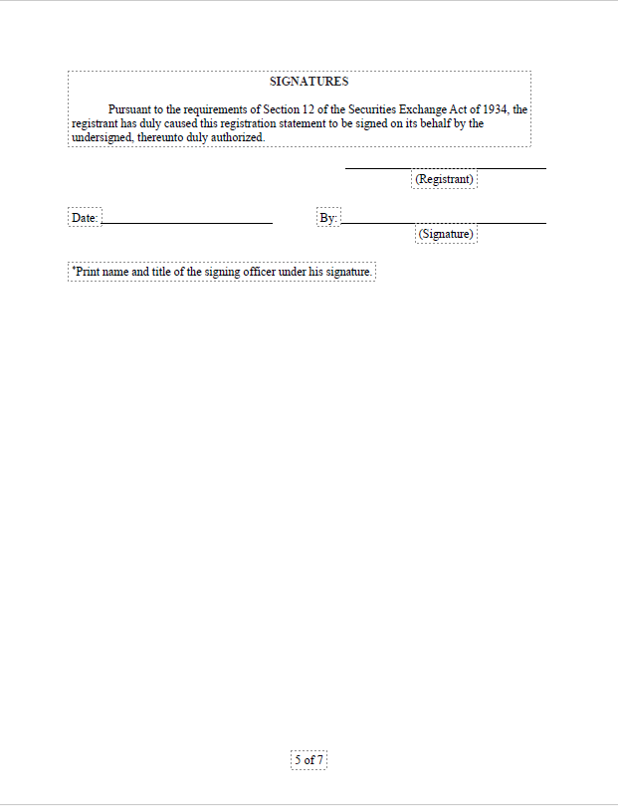
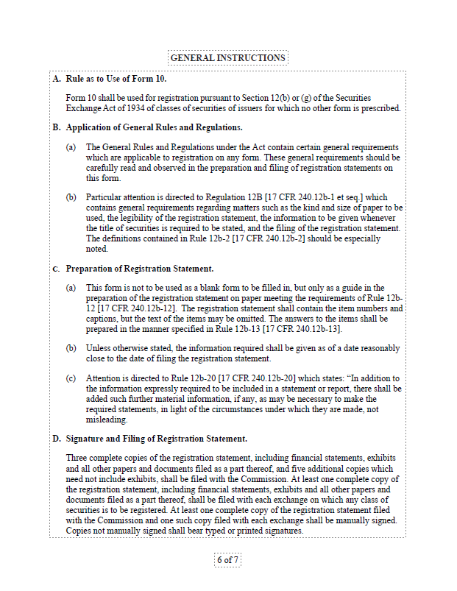
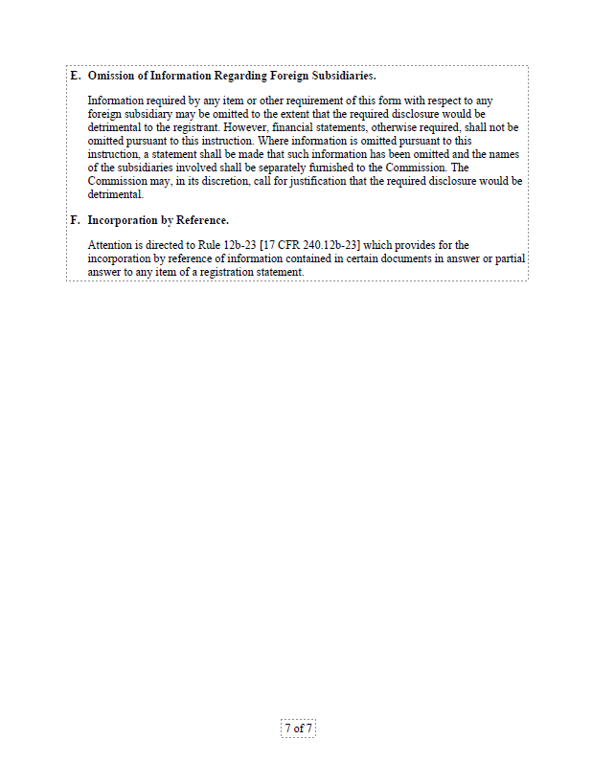

**A3. Listing Timeline Flexibility**
Question: What is the maximum timeframe allowed for completing the listing requirement?
- Is there a specific deadline from signing definitive agreements?
- What happens if listing is delayed due to market conditions beyond our control?
- Can the timeline be extended with mutual consent?
- Are there any penalty provisions for listing delays?

**A4. Listing Failure Contingency**
Question: In the event that listing cannot be completed due to market conditions, regulatory issues, or other factors:
- Does the entire investment agreement terminate?
- Are there alternative structures that could be implemented?
- Who bears the cost of aborted listing expenses?
- Is the $175,000 transaction expense refundable in this scenario?

SECTION B: DIVIDEND AND COMMITMENT FEE STRUCTURE

**B1. Dividend Calculation and Timing**
Question: Regarding the 9% per annum dividend on preferred stock:
- Does the dividend begin accruing immediately upon signing definitive agreements or only after each tranche is actually invested? Only after each tranche is drawdowned.
- Is the dividend calculated on the full $150M commitment or only on tranches actually drawn? Only on tranches actually drawn.
- If calculated on drawn amounts only, does it start from the date of each individual tranche closing? It is understood that it starts immediately after drawdown of each tranche.
- Is the dividend cumulative if not paid in any given period? If the Company decide not to pay dividend the accumulated fee will be transferred into “Preferred Shares” for the Investor.
When the 150 is reached Broadhill can transfer to common shares. There is no time limit for when to transfer to common stock.
Mont management on Fecex gives 18% annually in average.

**B2. Commitment Fee Calculation**
Question: Regarding the 6% per annum commitment fee:
- Does this fee apply to the full $150M from the effective date, or only to undrawn amounts? This applies the undrawn amount up to $150M.
- When does this fee start accruing - upon signing definitive agreements or term sheet acceptance? From the signing of the final agreement with Broadhill.
- Does the fee stop accruing when each tranche is drawn, or continue until all tranches are accessed? Yes.
- Is this fee payable quarterly, annually, or upon tranche drawdown? Not clarified

**B3. Combined Cost Clarification**
Question: To ensure we understand the total cost structure:
- In Year 1, if no tranches are drawn, would we pay 6% commitment fee on $150M ($9M) plus no dividend? YES
- Once Tranche 1 ($37.5M) is drawn, would we pay 9% dividend on $37.5M ($3.375M) plus 6% commitment fee on remaining $112.5M ($6.75M)? YES
- Is there any scenario where both fees apply to the same capital amount simultaneously? NO

**B4. Fee Payment Terms**
Question: What are the specific payment terms for these fees:
- Are payments due quarterly, semi-annually, or annually?
- Can fees be paid in equity rather than cash?
- What happens if the company cannot make a scheduled fee payment?
- Are there any grace periods or cure provisions for late payments?

SECTION C: PUT AND CALL RIGHTS MECHANICS

**C1. Put Right Exercise Conditions**
Question: Regarding the company's put right to force investor purchase:
- Can this right only be exercised after completing the public listing?
- Is there a minimum time period the company must wait after listing before exercising the put?
- What is the exact 3-year exercise window - from listing date or from definitive agreement signing?
- Can the put right be exercised for partial amounts or only for entire tranches?

**C2. Call Right Exercise Conditions**
Question: Regarding the investor's call right to force investment:
- When exactly can this right first be exercised - 1 year after listing or 3 years after effective date?
- Can the investor force investment during adverse market conditions or company performance issues?
- Is there any company veto right or market condition protection?
- What happens if the company cannot effectively utilize forced capital deployment?

**C3. VWAP Pricing Protection**
Question: Since both put and call rights reference VWAP pricing:
- What is the specific VWAP calculation period (10-day, 20-day, 30-day average)?
- Are there any collar provisions to protect against extreme market volatility?
- What happens if trading volume is insufficient for reliable VWAP calculation?
- Is there a minimum price floor or maximum price ceiling?

**C4. Put/Call Interaction**
Question: How do the put and call rights interact with each other:
- Can both rights be exercised simultaneously or are they mutually exclusive?
- If the investor exercises call rights, does this affect the company's subsequent put rights?
- Are there any standstill periods between exercises of these rights?

SECTION D: WARRANT COVERAGE AND DILUTION

**D1. Warrant Exercise Timing**
Question: Regarding the 100% warrant coverage:
- When do the warrants become exercisable - immediately upon issuance or after listing?
- What is the exact exercise period - is it 3 years from issuance or from listing?
- Can warrants be exercised in partial amounts or only in full?
- Is there any acceleration of exercise rights under certain conditions?

**D2. Warrant Exercise Price**
Question: How is the warrant exercise price determined:
- Is it set at the same price as the preferred stock investment?
- Does it adjust for stock splits, dividends, or other corporate actions?
- Are there any anti-dilution provisions that could lower the exercise price?
- What happens to the exercise price if the company's valuation changes significantly?

**D3. Maximum Dilution Scenario**
Question: To understand the worst-case dilution impact:
- If all warrants are exercised, what would be the maximum total dilution to existing shareholders?
- Is the 30% preferred stock ownership calculated on a fully-diluted basis including warrants?
- Could total investor ownership exceed 60% under any scenario?
- Are there any caps on total investor ownership percentage?

**D4. Conversion Mechanics**
Question: Regarding conversion from preferred to common shares:
- Is there a maximum time period after which preferred shares must convert to common?
- Can the company force conversion after a certain period or under specific conditions?
- What happens to accrued but unpaid dividends upon conversion?
- Are there any automatic conversion triggers (IPO, sale, etc.)?

SECTION E: CORPORATE RESTRUCTURING AND COSTS

**E1. Delaware Corporation Timeline**
Question: Regarding the requirement to reorganize as a Delaware C-corporation:
- What is the required timeline for completing this restructuring?
- Who bears the legal and administrative costs of the reorganization?
- Are there any Norwegian regulatory approvals required that could delay this process?
- What happens to existing Norwegian corporate contracts and licenses during restructuring?

**E2. Consolidated Assets Transfer**
Question: The term sheet requires consolidating all assets under the Delaware corporation:
- What specific assets must be transferred and by when?
- Who pays for the legal and administrative costs of these transfers?
- Are there any tax implications for existing shareholders from these transfers?
- What happens if certain assets cannot be legally transferred to a US entity?

**E3. Management Build-up Requirements**
Question: What specific management positions must be filled before listing:
- Is a US-qualified CFO with public company experience mandatory?
- Are there minimum experience requirements for key positions?
- Who bears the cost of recruiting and compensating these positions during the pre-listing period?
- Can existing Norwegian management fulfill some of these roles?

**E4. Pre-Listing Cost Allocation**
Question: Regarding costs incurred before accessing any investment capital:
- Beyond the $175,000 transaction expense, what other costs will the company bear?
- Are listing preparation costs (legal, accounting, investment banking) the company's responsibility?
- Can any of these costs be reimbursed from the first tranche?
- Is there an estimated total cost range for the complete listing process?

SECTION F: MILESTONE AND PERFORMANCE REQUIREMENTS

**F1. Tranche 3 and 4 Milestones**
Question: The term sheet states Tranches 3 and 4 require revenue and net book value thresholds marked as "TBD":
- What are the anticipated threshold amounts for these milestones?
- How are these thresholds determined and can they be negotiated?
- What happens if milestones are not met - do the tranches become unavailable permanently?
- Can milestone requirements be modified based on market conditions or company performance?

**F2. Milestone Measurement**
Question: How are the milestone achievements measured and verified:
- What accounting standards apply for revenue and net book value calculations?
- Who determines whether milestones have been achieved?
- Is there a dispute resolution process if parties disagree on milestone achievement?
- Can milestones be achieved through acquisitions or must they be organic growth?

**F3. Use of Proceeds Flexibility**
Question: The term sheet mentions use of proceeds "will be as specified in the definitive agreements":
- What restrictions, if any, will be placed on use of investment funds?
- Can proceeds be used for acquisitions, debt repayment, or working capital?
- Is there investor approval required for major capital allocation decisions?
- What reporting is required on use of proceeds?

SECTION G: MERGER AND ACQUISITION PROVISIONS

**G1. Contemplated M&A Activity**
Question: The term sheet references "contemplated" merger transactions:
- Are these acquisitions mandatory or optional strategic opportunities?
- Who identifies and approves potential acquisition targets?
- How are acquisition costs funded - from investment proceeds or separately?
- What happens if suitable acquisition targets are not available or affordable?

**G2. M&A Decision Authority**
Question: Regarding merger transaction decision-making:
- Does the investor have veto rights over potential acquisitions?
- What approval thresholds are required for different transaction sizes?
- Can the company pursue acquisitions not contemplated in the original agreement?
- How are acquisition valuations determined and disputes resolved?

**G3. Integration Requirements**
Question: For acquired companies and existing subsidiaries:
- Must all entities be reorganized under the Delaware corporation structure?
- What is the timeline for completing these integrations?
- Who bears the costs of legal and administrative integration?
- Are there any regulatory restrictions on consolidating certain maritime assets under US ownership?

SECTION H: EXISTING SHAREHOLDER PROTECTIONS

**H1. Existing Shareholder Rights**
Question: What protections exist for current shareholders:
- Do existing shareholders have any anti-dilution rights for future financing rounds?
- Are there tag-along or drag-along rights in case of investor exit?
- Can existing shareholders participate in future investment rounds on similar terms?
- What happens to existing shareholder agreements and voting arrangements?

**H2. Lock-up and Transfer Restrictions**
Question: Are there any restrictions on existing shareholder liquidity:
- Is there a lock-up period preventing existing shareholders from selling shares?
- Can existing shareholders sell shares in the public market once listed?
- Are there any right of first refusal provisions favoring the investor?
- What transfer restrictions apply during the investment period?

**H3. Board Representation**
Question: How will board composition change post-investment:
- How many board seats will the investor receive?
- Do existing shareholders retain majority board control?
- Are there any special voting rights or veto powers for the investor?
- What happens to board composition if additional tranches are not accessed?

SECTION I: EXIT AND TERMINATION SCENARIOS

**I1. Early Termination Rights**
Question: Under what circumstances can either party terminate the agreement:
- Can the company terminate if listing becomes impractical or too expensive?
- Can the investor terminate if company performance deteriorates?
- What are the financial consequences of early termination by either party?
- Are there any cure periods for addressing performance or compliance issues?

**I2. Investor Exit Scenarios**
Question: How can the investor exit their investment:
- Are there any forced sale or drag-along rights after a certain period?
- Can the investor demand registration rights for selling shares publicly?
- Are there any restrictions on investor transfer of preferred shares to third parties?
- What happens if the investor wants to exit before all tranches are accessed?

**I3. Change of Control Provisions**
Question: What happens in case of acquisition offers or change of control:
- Does the investor have any veto rights over sale transactions?
- Are there any minimum price or approval thresholds for sale transactions?
- How are liquidation preferences handled in a sale scenario?
- Can a change of control trigger acceleration of warrant exercise or conversion rights?

SECTION J: REGULATORY AND COMPLIANCE MATTERS

**J1. Norwegian Regulatory Compliance**
Question: How does the US investment structure affect Norwegian operations:
- Are there any Norwegian regulatory approvals required for this investment structure?
- Will Norwegian maritime licenses and permits remain valid under US parent ownership?
- Are there any restrictions on foreign ownership of Norwegian maritime assets?
- What ongoing compliance obligations exist in both jurisdictions?

**J2. US Securities Law Compliance**
Question: What ongoing US regulatory obligations begin immediately:
- When do SEC reporting requirements begin - upon investment or upon listing?
- What Sarbanes-Oxley compliance requirements apply during the pre-listing period?
- Are there any restrictions on business operations or transactions during the listing process?
- What disclosure obligations exist regarding the investment and listing plans?

**J3. Tax Implications**
Question: What are the tax consequences of this structure:
- How will the Delaware corporation structure affect Norwegian tax obligations?
- Are there any withholding tax implications for dividend payments to US investors?
- What transfer pricing considerations apply for inter-company transactions?
- Are there any tax optimization opportunities or risks we should consider?

SECTION K: OPERATIONAL AND STRATEGIC FLEXIBILITY

**K1. Business Operation Restrictions**
Question: What limitations exist on normal business operations:
- Are there any restrictions on entering new contracts or business lines?
- Do major operational decisions require investor approval?
- Can the company incur additional debt or enter into significant commitments?
- Are there any limitations on capital expenditures or strategic investments?

**K2. Management and Personnel Decisions**
Question: What investor rights exist regarding management:
- Does the investor have approval rights over key management appointments?
- Are there any restrictions on management compensation or equity grants?
- Can existing management be replaced if performance targets are not met?
- What happens if key personnel leave during the investment period?

**K3. Strategic Direction Authority**
Question: Who controls major strategic decisions:
- Can the company change its business strategy or focus areas without investor consent?
- Are there any restrictions on geographic expansion or market entry?
- What approval is required for major partnerships or joint ventures?
- How are conflicts between company strategy and investor preferences resolved?

SECTION L: FINANCIAL REPORTING AND TRANSPARENCY

**L1. Financial Reporting Requirements**
Question: What financial reporting obligations begin immediately:
- Are monthly, quarterly, or annual financial reports required to the investor?
- What accounting standards must be used (US GAAP, IFRS, Norwegian GAAP)?
- Are audited financial statements required before listing completion?
- What level of detail and transparency is required in financial reporting?

**L2. Performance Monitoring**
Question: How will company performance be monitored and evaluated:
- What key performance indicators (KPIs) must be reported regularly?
- Are there any performance benchmarks that could trigger additional investor rights?
- What happens if financial performance deteriorates significantly?
- Are there any early warning systems or intervention rights for the investor?

**L3. Information Rights**
Question: What ongoing information access does the investor receive:
- Does the investor have inspection rights for books, records, and facilities?
- Are there any confidentiality or competitive information restrictions?
- What level of operational detail must be shared with the investor?
- How are disputes over information access or confidentiality resolved?

SECTION M: MARKET AND VALUATION PROTECTION

**M1. Valuation Adjustment Mechanisms**
Question: Are there any provisions to address valuation changes:
- What happens if market conditions significantly deteriorate before listing?
- Are there any price adjustment mechanisms based on comparable company valuations?
- Can investment terms be renegotiated if fundamental business conditions change?
- Are there any minimum valuation guarantees or maximum dilution caps?

**M2. Market Timing Flexibility**
Question: How much flexibility exists around market timing:
- Can the listing be delayed if market conditions are unfavorable?
- Are there any provisions to optimize listing timing for maximum valuation?
- What happens if the maritime industry experiences a significant downturn?
- Can the investment structure be modified to adapt to changing market conditions?

**M3. Competitive Protection**
Question: How is competitive position protected during the transition:
- Are there any restrictions on investor sharing information with competitors?
- What happens if competitors make acquisition offers during the listing process?
- Are there any non-compete provisions preventing investor conflicts of interest?
- How is confidential business information protected throughout the process?

CONCLUSION

These clarifying questions address the key areas of ambiguity and potential concern identified in the term sheet. Obtaining clear answers to these questions will enable the board and shareholders to make a fully informed decision about proceeding with this investment opportunity.

We recommend prioritizing questions in Sections A (Listing Requirements), B (Dividend and Fee Structure), and D (Warrant Coverage) as these have the most immediate financial impact on the company and existing shareholders.

Document Prepared By: Tore Ausland
Classification: Board Review - Confidential
Distribution: Board of Directors and Key Shareholders that signed NDA only.

